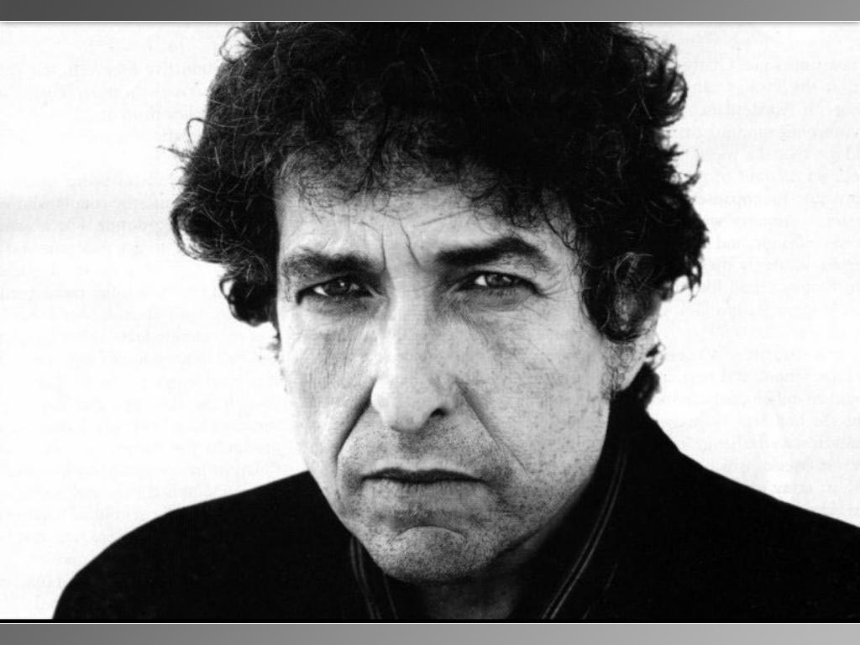

"When You Going to Wake Up ?" by Bob Dylan (1979)
God don't make promises that He don't keep
You got some big dreams baby, but in order to dream you got to still be asleep.
When you going to wake up, when you going to wake up
When you going to wake up strengthen the things that remain ?
Counterfeited philosophies have polluted all of your thoughts
Karl Marx has got you by the throat, Henry Kissinger's got you tied up in knots.
When you going to wake up, when you going to wake up
When you going to wake up strengthen the things that remain ?
You got innocent men in jail, your insane asylums are filled
You got unrighteous doctors dealing drugs that'll never cure your ills.
When you going to wake up, when you going to wake up
When you going to wake up strengthen the things that remain ?
You got men who can't hold their peace and woman who can't control their tongues
The rich seduce the poor and the old are seduced by the young.
When you going to wake up, when you going to wake up
When you going to wake up strengthen the things that remain ?
Adulterers in churches and pornography in the schools
You got gangsters in power and lawbreakers making rules.
When you going to wake up, when you going to wake up
When you going to wake up strengthen the things that remain ?
Spiritual advisors and gurus to guide your every move
Instant inner peace and every step you take has got to be approved.
When you going to wake up, when you going to wake up
When you going to wake up strengthen the things that remain ?
Do you ever wonder just what God requires ?
You think He's just an errand boy to satisfy your wandering desires.
When you going to wake up, when you going to wake up
When you going to wake up and strengthen the things that remain ?
You can't take it with you and you know that it's too worthless to be sold
They tell you, 'Time is money' as if your life was worth its weight in gold.
When you going to wake up, when you going to wake up
When you going to wake up and strengthen the things that remain ?
There's a man up on a cross and He's been crucified for you
Believe in His power that's about all you got to do.
When you going to wake up, when you going to wake up
When you going to wake up and strengthen the things that remain ?

Bob Dylan was an outspoken and sometimes controversial activist in the 60’s & 70’s. He used his music to get his message across.

Questions:
1. What type of poem is this?
I think that this type of poem is about the things that are going wrong in the world.
2. What do you think Dylan’s purpose is?
Dylan’s purpose is to tell us about that things in order to realize and think about the things that are going wrong in which we can figure out ways to improve it.
3. What do think the significance of the repetition is?
I think that the significance of the repetition is that Bob Dylan is convincing and persuading us to understand and improve and think about all these problems that are going on in the world.
4. What do you think are the “things that remain”?
I think that the term “things that remain” means that they are talking about the specific things that are the remaining problems going on in our world.
5. Note the figures of speech used.
These figures of speech are highlighted in these colours corresponding to their literary device:
Turquoise: Alliteration
Lime: Allusion
Green: Metaphor
6. This song was written in 1979 – do the messages still hold true today? Explain.
Clearly, these messages hold true today because there are things going wrong in our world and if we don’t improve that or even realize or think about it, we would be in doom and many people would be living in a dire strait.

DO NOT GO GENTLE INTO THAT GOOD NIGHT by Dylan Thomas
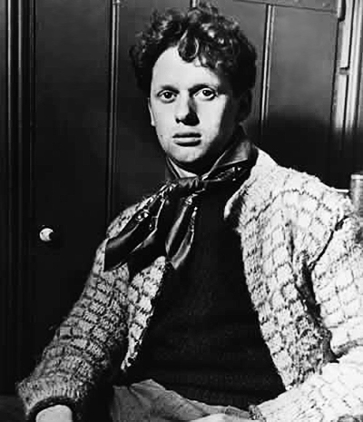
Do not go gentle into that good night,
Old age should burn and rave at close of day;
Rage, rage against the dying of the light.
Though wise men at their end know dark is right,
Because their words had forked no lightning, they
Do not go gentle into that good night.
Good men, the last wave by, crying how bright
Their frail deeds might have danced in a green bay,
Rage, rage against the dying of the light.
Wild men who caught and sang the sun in flight,
And learn, too late, they grieved it on its way,
Do not go gentle into that good night.
Grave men, near death, who see with blinding sight
Blind eyes could blaze like meteors and be gay,
Rage, rage against the dying of the light.
And you, my father, there on the sad height,
Curse, bless me now with your fierce tears, I pray.
Do not go gentle into that good night.
Rage, rage against the dying of the light.

Dylan Thomas was one of the most famous 20th century poets. He used short, strong words and clear images to impress his idea upon the reader. This is one of his most famous poems and he is speaking to his father as he (the father) lays dying of old age.

Questions:
1. What type of poem is this?
I think this type of poem is about the intensity and power of familial bonds that connect with each other.
2. What do you think Dylan’s purpose is?
I think Dylan Thomas’s purpose is that the people that are dying or extremely sick and the elderly should fight against death.
3. What do think the significance of the repetition is?
I think the significance of the repetition is that Dylan Thomas is convincing and persuading us to not give up death to easily and fight hard with it. This way, he is telling us to try to live a long life.
4. Note the figures of speech used.
Purple: Alliteration
Red: Assonance
Teal: Personification
5. This poem was written in 1851 – do the feelings Thomas expresses still hold true? Explain.
I think that these feelings of Dylan Thomas still hold true because the way he feels for his father desperately fighting over death as well as if he didn’t write this poem, he wouldn’t have had expressed those feelings or have even written the poem in this type of state.

